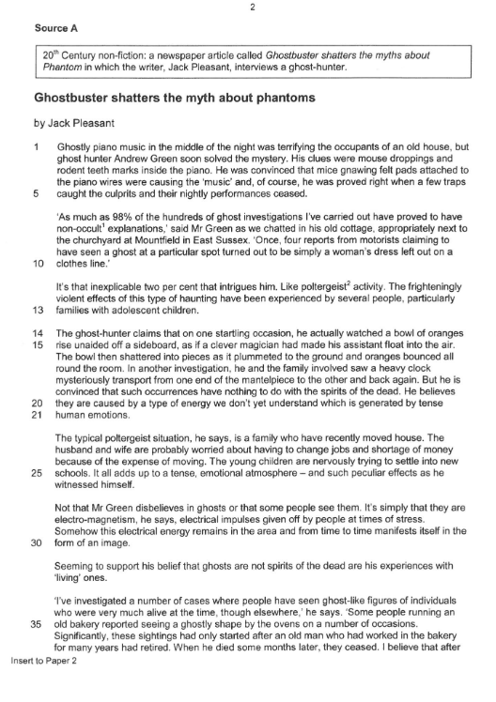

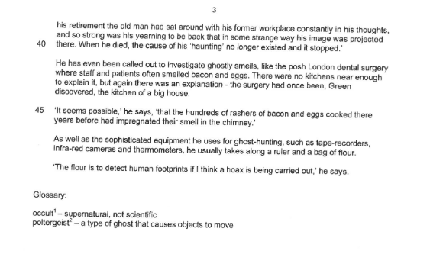

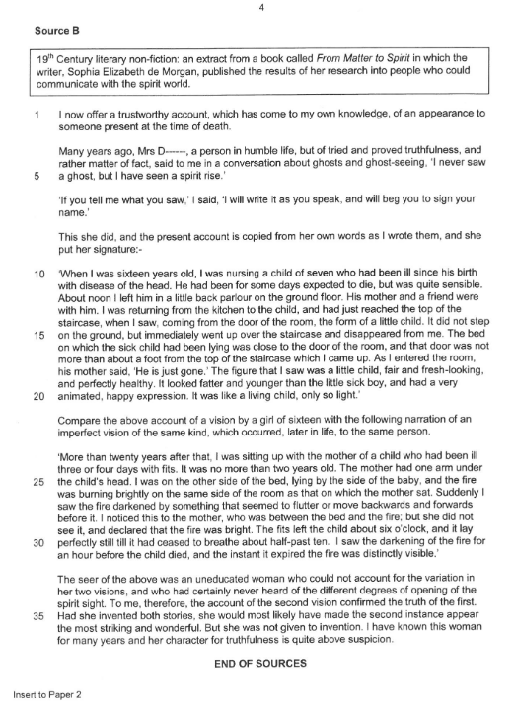

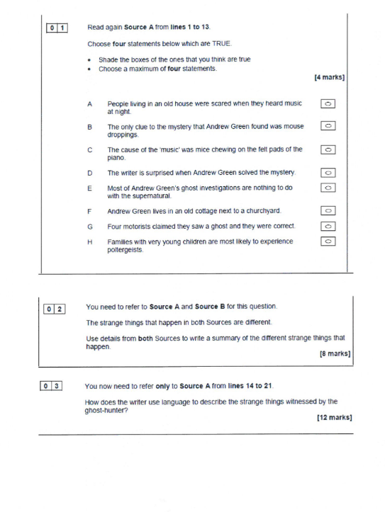 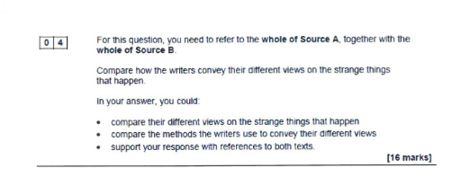

Section B

We live in a world where science explains everything. We have no need for tales about ghosts.

Write an article in which you argue your view on this statement.

40 marks

24 marks for content and organisation

16 marks for technical accuracy