Employability skills project

“Workplace ready”

This project should be completed individually

You will need to complete a set of different tasks and provide proof of completion

At the end you should upload all your work to the workbook provided at the end of this hand-book. The video presentation (5 minutes) will have to be uploaded separately on Teams assignment platform

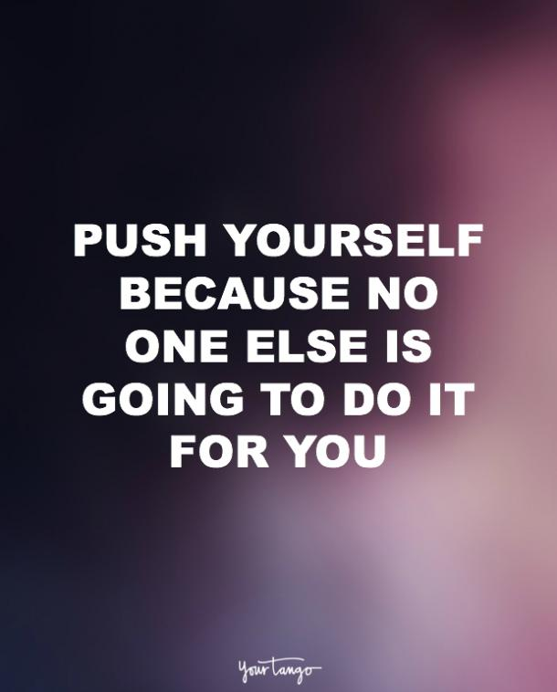
What you will learn during this project:
- Recognise the importance of interpersonal skills
- Job knowledge, dream career recognition and relevant skills identification
- Self-reflection on your choices

You will also develop:

Your research skills

Online learning skills

Presentation skills

Digital skills

Student ID:

Task 1

The importance of interpersonal skills
After completing this course in your workbook answer the following questions:
- Why do you think interpersonal skills are important? (100 words)
- Please describe how do you think the communication with others can influence working relationships? (100 words)
- How this course will help you to better perform when working in teams or groups for your assignments? (100 words

*Please double click on the PDF file to test if it is possible to open it
Please upload your certificate:

Task 2

Interview skills workshop
*Please double click on the PDF file to test if it is possible to open it
Upload pdf of Elevator pitch
(double click on the file to see example)
Upload pdf of Questions
(double click on the file to see example)
Please answer the following question: Please reflect on how this Interview course will help you in your future? (min 50 – max 100 words)

Task 3

Part 1

National Career Service quick skills assessment:
After completing your test please list the 10 career areas that might interest you based on the test results.
Choose one of the 10 careers and carry on to complete extra questions. Based on your further answers chose one role from those that you have been offered.  Click on that role to see the detailed description.  From the section called ‘What it takes’ select 4 skills/knowledge you think you already have.  (think about what you think you are good at or which qualities stand out to you the most) | Role:  4 skills you already have. Using one sentence describe the situation where you developed this skill:
Please add your reference code of your assessment:

Part 2

My Dream Career
Describe your dream career. (50 words)

Find one job advertisement for your dream career and share the link in the tab. This can be any kind of job or apprenticeship as long as this is something that relates to your dream career.

You might want to use these platforms to find the advertisement (click on each caption to access the web):
- Indeed
- Totaljobs
- GOV.UK
- Reed.co.uk
- Monster.co.uk
- Apprenticeships
From the job advertisement that you chose please select and list 5 skills needed for your dream job.
What is the salary for your chosen job?
List 3 main responsibilities of this job.

Part 3

Case-study

The video needs to be submitted no later than 28th June 2021

Please prepare a short 5 minutes creative video presentation on the following points. Please film the video and upload it on teams assignment tab.
- Tell us about the company and the industry it operates in
- Its aims and values
- The services it provides
- Products it sells
- The challenges it is facing, e.g. from competitors; or from Political, Economic, Social or Technological (PEST) changes
- Why would you like to work for company like this?

Have you uploaded your video to the Teams assignment tab? | YES / NO

Task 4
Select one of the iDEA badges that relates to your dream career and submit the following:
What bage did you decided to complete? Please put the category (e.g citizen; worker; marker; entrepreneur) and the name of the badge selected.

Why did you chose this badge? ( 50 words)

What did you learn during this activity? (100 words)

How will you apply this learning towards your dream career aspirations?

Task 5
*Please double click on the PDF file to test if it is possible to open it
Upload your record of achievements
(double click on the file to see example)

Task 6

Digital Skills: Digital Skills for Work and Life
Please answer the following:
What did you learn from this course?
How will this learning help you in your future?
Please upload your certificate:
(Your certificate should appear in your profile section ‘Achievements’)

*Please double click on the PDF file to test if it is possible to open it

Statement of originality and plagiarism:
I hereby declare that this submission is my own work and to the best of my knowledge it contains no materials previously published or written by another person, or substantial proportions of material which have been accepted for the award.
By signing below you agree with the statement above.
Full name:
Student email:
Date:

