Commonwealth war graves: new memorials to honour black and Asian soldiers at last
Mark Bridge, History Correspondent Thursday April 22 2021, 12.00am, The Times
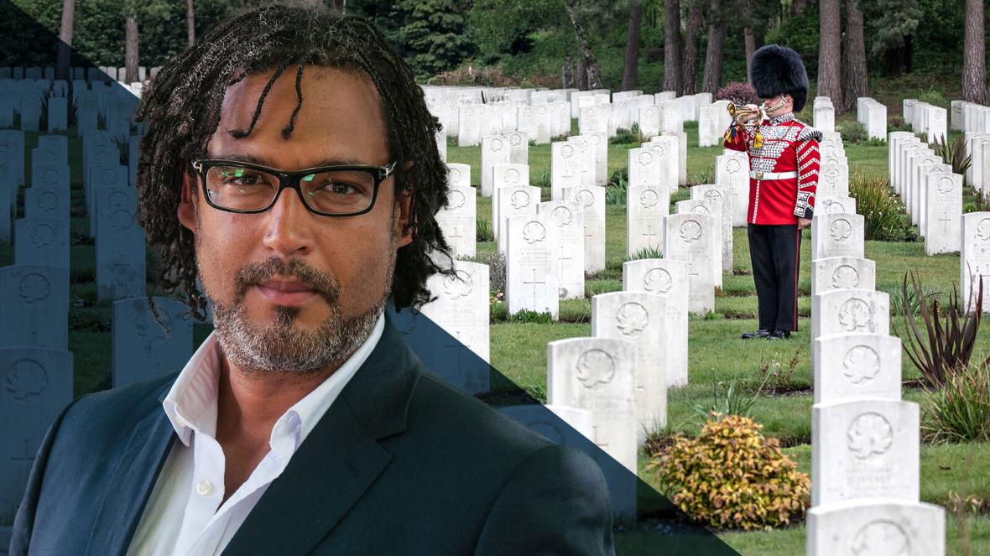
Professor David Olusoga says the failure to commemorate black and Asian soldiers is a scandal
Britain will build new memorials to black and Asian service personnel who died fighting for its empire after hundreds of thousands were not commemorated.
The government apologised yesterday for historical failures by which “pervasive racism” underpinned a failure to properly commemorate personnel from the colonies.
Ben Wallace, the defence secretary, said in the Commons that the unequal treatment identified in a report was inexcusable. A special committee convened by the Commonwealth War Graves Commission found that at least 116,000 such casualties, and perhaps as many as 350,000, were not commemorated by name and some were not commemorated at all.
A further 45,000-54,000 other casualties were commemorated unequally, according to the committee. It found that the failure to memorialise these casualties adequately was rooted in “the entrenched prejudices, preconceptions and pervasive racism of contemporary imperial attitudes”.
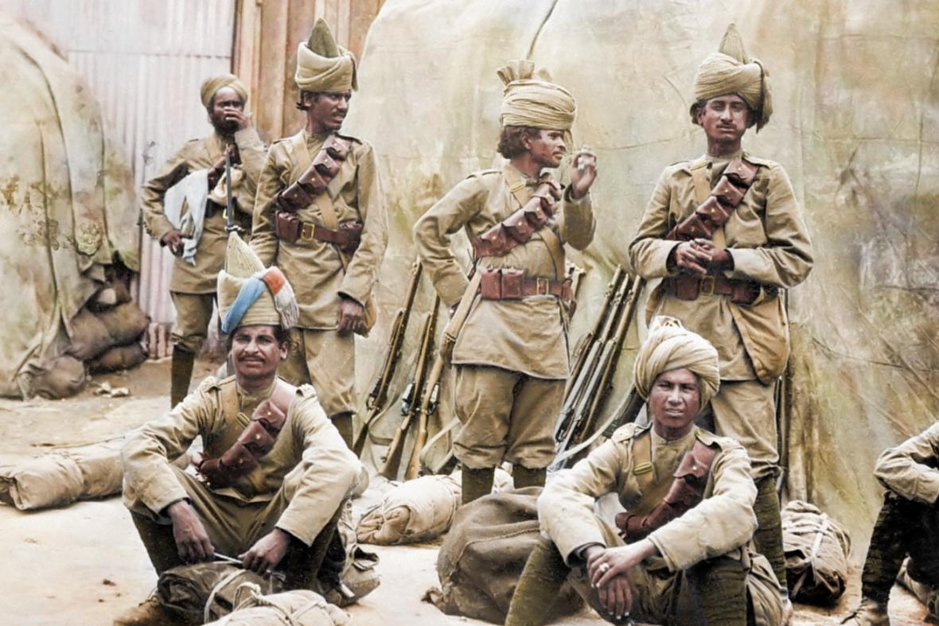
Indian soldiers on the Western Front in the First World War. Many from the colonies were not commemorated by name
ROYSTON LEONARD/MEDIADRUMIMAGE
Wallace said: “On behalf of the Commonwealth War Graves Commission and of the government both of the time and of today I want to apologise for the failures to live up to their founding principles all those years ago and express deep regret that it has taken so long to rectify the situation.”
In Sierra Leone, 795 names of those who should have been commemorated will, after consultation, be added to a new memorial within the next two years. The commission said it was too soon to be specific on how many new memorials elsewhere would be required, “but where absences in commemoration can be corrected, they will be, in a timely manner”.
In other cases, the commission said that names would be added to existing “nameless memorials”. It said decisions on how personnel were memorialised would hinge on discussions with local communities and that some memorials would probably be digital. It is understood that the commission does not want to cause controversy by erecting Menin Gate-style memorials across Africa.
In addition, the commission will seek to add all known names of previously uncommemorated casualties to an online database.
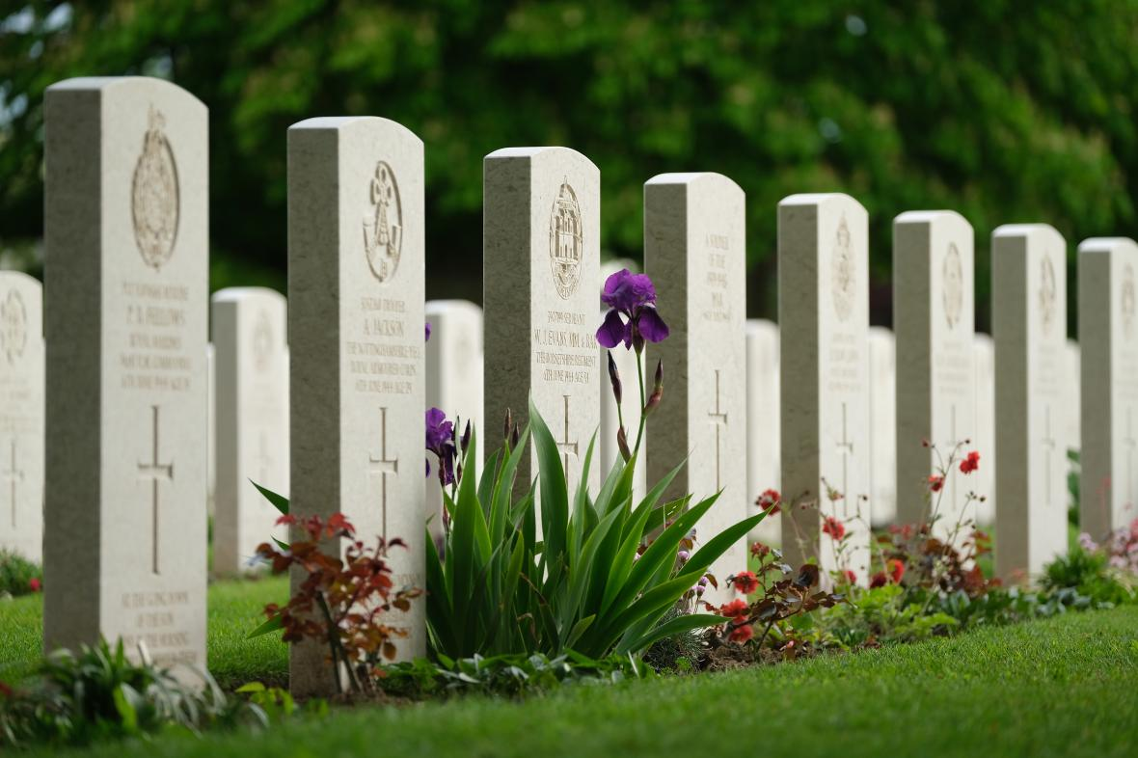
The Commonwealth War Graves Commission said it was not aware of the scale of the issue
SEAN GALLUP/GETTY IMAGES
Wallace, a former captain in the Scots Guards, said that “true soldiers are agnostic of class, race and gender because the bond that holds us together is a bond forged in war . . . those common bonds were what lay behind the Imperial War Graves Commission’s principles and it is truly sad that on the occasions identified by the report those principles were not followed. I feel it is my duty as a former soldier to do the right thing by those who gave their lives in the First World War across the Commonwealth and take what necessary steps we can to rectify the situation.”
This morning David Olusoga, professor of public history at Manchester University, said that Britain’s failure was one of the worst scandals he had come across in his career.
Olusoga, whose television company produced the 2019 documentary Unremembered: Britain’s Forgotten War Heroes, which led to the investigation, told Today on BBC Radio 4: “It is a war that deeply changed our culture, and part of the impact of the First World War was the power of the way those who fell were memorialised. When it came to men who were black and brown and Asian and African, it is not equal, particularly the Africans who have been treated in a way that is, as I said, it’s apartheid in death.
“It is an absolute scandal. It is one of the biggest scandals I’ve ever come across as an historian, but the biggest scandal is that this was known years ago.”
Olusoga said the Commonwealth War Graves Commission, under its previous leadership, “chose to ignore” the work of Professor Michèle Barrett, highlighting inequalities in commemoration that were counter to the commission’s stated ideal of equality of treatment in death.
David Lammy MP, who presented the documentary, told the BBC that while making the film in Kenya and Tanzania, he discovered mass graves in which Africans had been “dumped with no commemoration whatsoever”. He said it was a travesty that men who served the British Empire were not commemorated properly, but welcomed the report. “I’m just really, really pleased that the dignity that these men deserved — who were dragged from their villages and commandeered to work for the British Empire — that dignity that they deserve in death can be granted to them,” he said.
Altogether the report estimates that more than three million British colonial and dominion subjects served in the First World War and more than 500,000 died. While about a third of those serving were from the “white-settled dominions of Canada, Australia and New Zealand”, they were only “one part of a much bigger global story”. It refers to remarks by colonial officials, stating that many Africans had “primitive principles and do not bury their dead” or did not “attach any sentiment to marking graves” among other evidence of “entrenched prejudices”.
It quotes Sir Fabian Ware, founder of what was then the Imperial War Graves Commission, as stating in 1922 that, if in a colonial setting, a governor wanted a form of commemoration not in accordance with the commission’s usual policy of equality of treatment, “we should, for many reasons, comply with their wishes and advice as far as possible”.
The war graves commission today apologised “unreservedly” for the failings highlighted in the report and committed to implement a set of ten recommendations contained in it. This work will include searching for the identities of unnamed war dead, building new physical memorials and commemorating more casualties online. Regarding new physical memorials, it said it was “too soon to be specific on how many, where or when these may be required but where absences in commemoration can be corrected, they will be, in a timely manner”.
Comment: It can never be put right, but it’s a start
I do feel a bit shocked that it takes a Channel 4 documentary to produce action when decades of academic papers have been ignored. Over the years the Commonwealth War Graves Commission has been resistant to taking this step (Michèle Barrett writes).
My research started after I took students to the Indian memorial at Neuve Chapelle in France. I decided to compare what happened there with what happened with the Basra memorial in what is now Iraq. I found that at Basra the Indian rank and file whose names they had were not on the memorial. I was shocked. That’s when I thought, if they did that with the Indians, what did they do with the Africans?
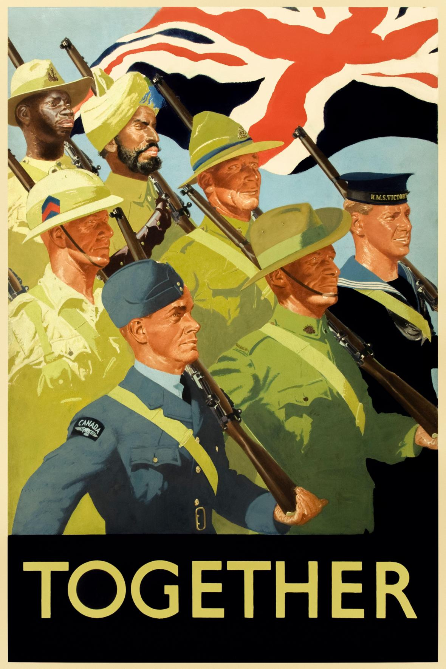
A Second World War poster
I wrote to the commission in 2007 with my initial research. It wrote back neutral letters, saying, “Yes, by modern standards it’s not very good, is it?”
Shortly afterwards I suggested that it might collaborate with me on research in its archives, but had no response. However, there’s a new generation of people running the commission and they are much more open to looking at it seriously. Our report says that the commission’s history has been sanitised. I think it has been important to the commission to be seen to be egalitarian because what it did with equality of treatment of the dead was controversial and progressive at the time in terms of social class and military rank. It’s just that it didn’t continue that policy outside Europe.
I think it’s going to be difficult to implement all the recommendations. They’re going to have to do things which are a long way from their comfort zone.
Apparently people in the organisation are shocked at how far-reaching this is — they thought that a few people had been missed. That it is a number that could be as high as a third of their First World War database is a big thing to digest.
It can never be put right. How could it be? But time and money can be spent trying to identify casualties.
At the mass burial site that we found in the [Unremembered] documentary, people told us the spirits were unhappy there. There was a lot of local feeling that this was an unresolved site. I think — this is a long way from the protocols of the commission — that they could have a ceremony of apology and closure and that could be helpful. But they have got to discuss this with the communities involved and I don’t think they’re going to find that so easy.
Professor Michèle Barrett’s research uncovered the extent to which black and Asian casualties were not given equal treatment by the Imperial War Graves Commission, now the Commonwealth War Graves Commission. She was a member of the commission’s special committee, which published findings on this unequal treatment yesterday

‘Apartheid’ left black and Asian war dead unhonoured, says David Olusoga

Commonwealth War Graves Commission issues apology
Mark Bridge, History Correspondent Thursday April 22 2021, 12.00pm, The Times

Britain’s failure to properly commemorate hundreds of thousands of black and Asian service personnel who died fighting for its empire amounts to “apartheid in death”, according to a leading historian who described it as “one of the biggest scandals I’ve come across”.
Professor David Olusoga was responding to a report today which said that at least 116,000 such casualties of the First World War, and perhaps as many as 350,000, were not commemorated by name by the Commonwealth War Graves Commission (CWGC). In some of these cases they were not commemorated at all.
Olusoga added that the biggest scandal to his mind was that this was known to researchers almost a decade ago.
A further 45,000 to 54,000 other casualties were commemorated unequally, according to a special committee appointed by the commission. It found that the failure to adequately memorialise these casualties was underpinned by “pervasive racism”.
Altogether the report estimates that more than three million British colonial and dominion subjects served in the First World War and more than 500,000 died. While about a third of those serving were from the “white-settled dominions of Canada, Australia and New Zealand”, they were only “one part of a much bigger global story”. It refers to historical remarks by colonial officials, stating that many Africans had “primitive principles and do not bury their dead” or did not “attach any sentiment to marking graves” among other evidence of “entrenched prejudices”.
It quotes Sir Fabian Ware, founder of the CWGC, formerly the Imperial War Graves Commission, as stating in 1922 that if, within a colonial setting, a governor wanted a form of commemoration not in accordance with the commission’s usual policy of equality of treatment, “we should, for many reasons, comply with their wishes and advice as far as possible”.
Ben Wallace, the defence secretary, said in the Commons this morning that the unequal treatment identified in the report was “inexcusable”. He said: “On behalf of the Commonwealth War Graves Commission and of the government both of the time and of today I want to apologise for the failures to live up to their founding principles all those years ago and express deep regret that it has taken so long to rectify the situation.”
Wallace, a former captain in the Scots Guards, said that “true soldiers are agnostic of class, race and gender because the bond that holds us together is a bond forged in war . . . those common bonds were what lay behind the Imperial War Graves Commission’s principles and it is truly sad that on the occasions identified by the report those principles were not followed. I feel it is my duty as a former soldier to do the right thing by those who gave their lives in the First World War across the Commonwealth and take what necessary steps we can to rectify the situation.”
Olusoga, whose television company produced the 2019 documentary Unremembered: Britain’s Forgotten War Heroes, which led to the investigation, told Today on BBC Radio 4: “It is a war that deeply changed our culture, and part of the impact of the First World War was the power of the way those who fell were memorialised. When it came to men who were black and brown and Asian and African, it is not equal, particularly the Africans who have been treated in a way that is, as I said, it’s apartheid in death.

“It is an absolute scandal. It is one of the biggest scandals I’ve ever come across as an historian, but the biggest scandal is that this was known years ago.”
Olusoga said that the Commonwealth War Graves Commission, under its previous leadership, “chose to ignore” the work of Professor Michèle Barrett, highlighting inequalities in commemoration, which flew counter to the commission’s stated ideal of equality of treatment in death.
Olusoga said that he first read Barrett’s research papers in 2012, adding: “This information was in my book The World’s War in 2014 and this has not been a secret. This information has been known. It’s been known to historians. It’s been known to the Commonwealth War Graves Commission.”
He added: “I think the question that the Commonwealth War Graves Commission needs to ask itself urgently is what would it be doing, what action would it be putting in place this morning, if it had learnt that 100,000 white soldiers on the western front had been left in the ground with no memorial or left in mass graves, the sites of their mass graves had been built over or ignored, what would they be doing?”
The war graves commission today apologised “unreservedly” for the failings highlighted in the report and committed to implement a set of ten recommendations contained in it. This work will include searching for the identities of unnamed war dead, building new physical memorials and commemorating more casualties online. Regarding new physical memorials, it said that it was “too soon to be specific on how many, where or when these may be required but where absences in commemoration can be corrected, they will be, in a timely manner”.
Olusoga said that the CWGC’s initial response to the Unremembered documentary — which featured Barrett’s work and was presented by David Lammy, the Labour MP — was not to launch a committee but instead was “annoyance and anger”.
He added: “The first attempt to put a committee together excluded Professor Barrett, and I know that because they invited me to sit on it and not her.
“I’m very pleased this is all happening but it has been somewhat reluctant, it has been somewhat dragged down to the Commonwealth War Graves Commission.”
A CWGC spokesman said: “We are grateful to Professor Barrett, David Lammy and David Olusoga for their work to cast a spotlight on these issues — work which provided important foundations for the detailed and comprehensive work of the special committee and the historians and archivists who supported it. They have been instrumental in informing the special committee report and have been invaluable in helping the commission to act where issues have been identified.
“The scale of the issue was not understood by the commission until this work took place. Now that we fully understand the scale of the issue, we are sorry and intend to act immediately. The answer to what we would do if these men and women were white is what the commission is doing today and moving forward — welcoming the committee’s no-holds-barred report, embracing all of its ten detailed recommendations and acting immediately and comprehensively to right the wrongs of the past.”

