Paper 1 Question 5 example questions:

Q5: Your school is asking students to contribute some creative writing for its website.
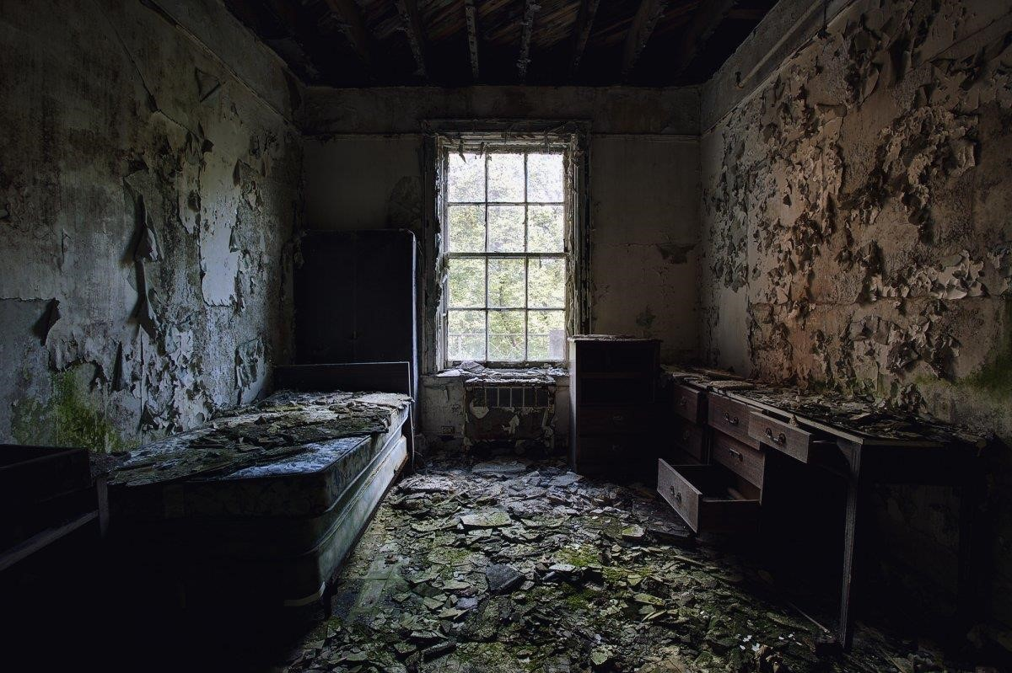
EITHER: Write a description as suggested by this picture
OR: Write a short story that begins with the sentence: “Suddenly, I heard it. It was coming from the other side of the passage.”
(24 marks for content and organisation
16 marks for technical accuracy)
[40 marks]
Q5: Your school magazine will be publishing a collection of creative writing written by students
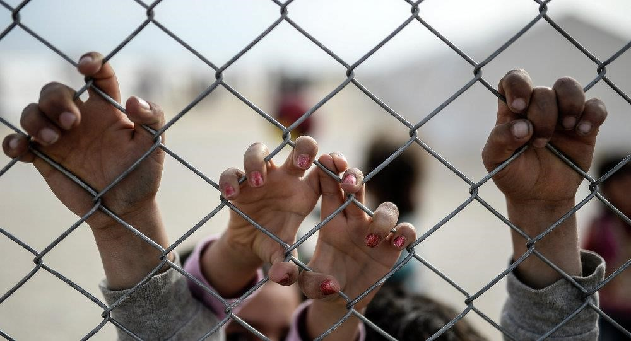
Either: Write a story about a conflict as suggested by this image
OR: Write a description about a place that has had a lasting impression on you.
(24 marks for content and organisation
16 marks for technical accuracy)
[40 marks]
Q5: A website has asked for examples of creative writing for its new page.
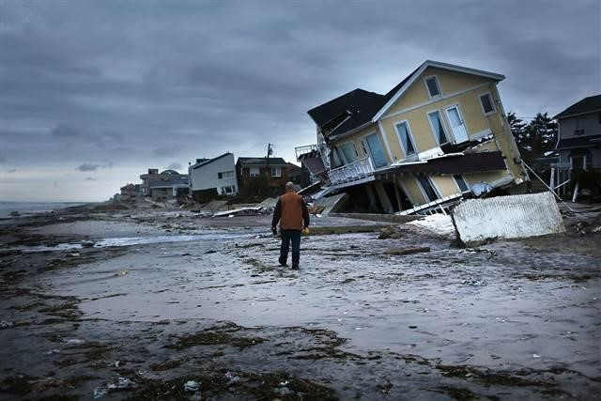
EITHER: Write a description as suggested by this picture
OR: Write a short story that begins with the sentence: “It was a disaster. I didn’t know what to do.”
(24 marks for content and organisation
16 marks for technical accuracy)
[40 marks]

