**How Strive Masiyiwa became Britain’s first black billionaire**

**The Econet Global founder fought the Mugabe regime to build Zimbabwe’s first mobile phone network. Now he lives in Surrey with his wife, Tsitsi**

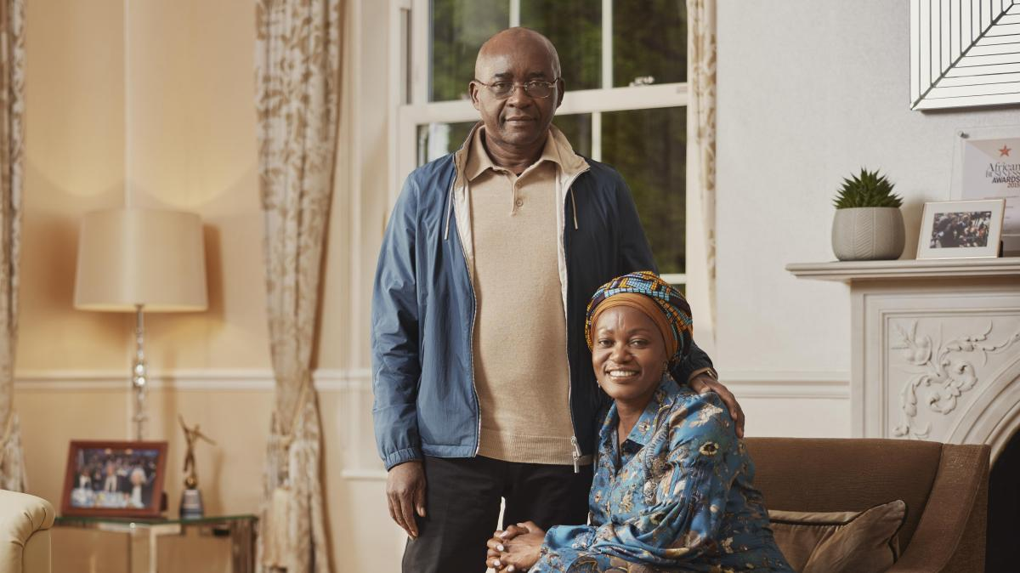

Strive Masiyiwa with his wife, Tsitsi, at home in Surrey

TOM BARNES FOR THE SUNDAY TIMES MAGAZINE

[John Arlidge](https://www.thetimes.co.uk/profile/john-arlidge)

Friday May 20 2022, 6.00am, The Sunday Times

**Net worth: £2bn ▲ £913m on 2021  
Source of wealth: Telecoms  
Rank on the Rich List: 89= ▲ 70 on 2021**

[Strive Masiyiwa](https://www.thetimes.co.uk/article/strive-masiyiwa-7j79dcsl9) was born in the townships near what was then Salisbury, Rhodesia — now Harare, Zimbabwe. The family house did not have a phone. Few Zimbabweans did back in the Sixties — most had never even heard one ring. Fast forward only a couple of generations and today almost all Africans have mobile phones, many with a web connection. The reason? “We’ve spent $3.5 billion plumbing the continent with fibre-optic cable from the Cape to Cairo, using picks and shovels,” Masiyiwa says.

The “we” he’s talking about is one of his firms, Cassava Technologies, which is based in London. Its subsidiary, Liquid Intelligent Technologies, has dug more than 60,000 miles of trenches alongside potholed highways and dust roads from South Africa through the whole of sub-Saharan Africa to Egypt. More than 10,000 African telecoms companies and large businesses in more than 20 countries rent bandwidth on the network, generating revenues of $800 million a year. Liquid is also the biggest data centre provider across Africa.

Masiyiwa, 61, runs his own businesses on the network, notably Sasai, an all-purpose communications, social media and global mobile phone banking app designed for use in Africa, and a mobile money service called EcoCash in Zimbabwe, Lesotho and Burundi. Along the way he has founded and floated scores of mobile phone operators across the continent and built South Africa’s 5G network for Vodafone. “Only Coca-Cola operates in more African countries than us,” he says, laughing.

His success has made him Britain’s first black billionaire, worth £2 billion on [this year’s list](https://www.thetimes.co.uk/sunday-times-rich-list), although he prefers not to advertise it. Yes, he now lives in a vast mansion in a Surrey private estate beloved of oligarchs after leaving Zimbabwe 22 years ago. But he’s wearing no-label sneakers, chinos and the kind of knitwear that could be from Zara unless you’re really in the know. (It’s Loro Piana, since you ask.)

He wants many more African entrepreneurs to follow in his footsteps. “Africa has a population of 1.3 billion people, 50 per cent of whom are under the age of 20, the youngest of any continent. It’s our job to build the digital infrastructure because every step we take creates jobs and we know what happens when young people don’t have jobs. You get Boko Haram, Al-Shabab, child soldiers in Liberia.”

That’s why he spends as much free time as he can muster away from worrying about latency and megabits per second on his networks mentoring African entrepreneurs. He uses Sasai and Facebook “to train entrepreneurs by sharing my experience. They can’t connect with Elon Musk or Bill Gates. It’s important that they can connect with someone from the continent. I’m speaking to millions of young Africans.”

He also runs a scholarship programme for westerners to work in Africa and then return home to — he hopes — talk up investment opportunities. “We take young Americans and distribute them among companies working in Africa. Not necessarily an African company. It could be General Electric or Vodafone. If someone goes to Africa when they are young, they retain a connection. These people have the right perspective of Africa. We say, ‘Come and work but then go back to your world and advocate for Africa.’ ”

Away from business he has led the fight against Covid in Africa. Scientists had feared the continent would be one of the worst affected in the world, with some projecting that as many as 20 million would die. For two years after the pandemic hit he chaired the African Vaccine Acquisition Task Team, reporting to the leadership of the African Union. He helped governments and donors to get hold of much-needed PPE and more than 1.6 billion doses of vaccines. “Today we have more than we need.”

He has persuaded Moderna, Pfizer and Johnson & Johnson to set up factories to make vaccines on the continent from Senegal to South Africa, should the worst happen again. “There are 14 all-new vaccine manufacturing projects that will be able to produce 250 million doses of vaccines a year,” he says. Thanks in part to his efforts — and the continent’s youthful population — the death toll has been remarkably low: “only” a few hundred thousand. “We got off reasonably well.”

How did he get here? The hard way, something his mother, Edith, seemed to know when she named him Strive. “She wanted me to try hard at everything that I do.” (History does not record what dreams Mrs Masiyiwa had for his brother, Nigel.)

His parents were forced to flee Rhodesia in 1964 when Masiyiwa was three years old because they were involved in the underground political opposition movement that eventually toppled the white minority government of Ian Smith. Masiyiwa lived with his grandmother in Rhodesia until he was seven, when he joined his parents in Kitwe, in the Copperbelt province in neighbouring Zambia, where they had ended up; his mother working as an entrepreneur and his father in mining.

It was there that the young Masiyiwa got his first job. “I asked my mother for pocket money. She bought me a big box of small packets of chewing gum and said, ‘You sell that. Bring me the money. And I’ll give you another one for yourself or to sell.’ ”

Exile was painful for his family but it was the making of Masiyiwa. One of the family’s new neighbours in Zambia sent their son to Holt School, a boarding school in Edinburgh. His mother and father scraped together the cash for him to go too. The 12-year-old hated it. “I was crying. It was bitterly cold. They said, ‘You have to wear your kilt on Sunday.’ I looked at them and their bare legs, and thought, ‘This is it. I’m dead.’ ”

By now, the *chimurenga*— war of liberation — against the Smith regime was raging and the young Masiyiwa left Scotland after O-levels and returned to Zambia in 1978 to join the armed struggle. He turned up to a training camp to sign up “but, to my surprise, the commander said to me, ‘We need guys like you to go back to school to help run the country after liberation.’ ” He returned to Britain — to Birkenhead — to live with family friends and do his A-levels before going on to study engineering at Cardiff University.

Zimbabwe was an independent country by the time he returned in 1984, aged 23. Thanks to his engineering skills he got a job designing networks for the state-run telephone company ZPTC. But he found the bureaucracy stifling — “It took years to get a line installed!” So he quit in 1987 and used $75 of savings to start a construction and engineering business called Retrofit “building houses for local people”.

He expanded into telecoms in 1993, when Motorola asked him if he would be interested in raising funds to create a satellite phone network across Africa. He failed to find backers but became convinced that simpler GSM mobile phone networks would be huge. So he got back in touch with his former colleagues at ZPTC and proposed a joint venture to create Zimbabwe’s network. “They told me to get lost! They said they had a monopoly on telecommunications and, besides, mobile phones were a fad that would never take off.”

Masiyiwa decided to challenge ZPTC in court. “How can anyone have a monopoly over something they do not want to do?” he wondered. The trouble was, this meant suing the government, then led by the increasingly autocratic president Robert Mugabe. “When I filed the lawsuit, oh my goodness, Mugabe went on TV and attacked me as an agent of a foreign power. A CIA agent trying to overthrow the government. I was public enemy number one.” Diplomats joked darkly that he was more likely to be killed than win his case.

Remarkably he not only survived, he won — after a five-year battle. He went on to build Zimbabwe’s first mobile phone network — Econet Wireless. But Mugabe was not done with him. Still sore at losing the legal battle, he publicly accused Masiyiwa of funding Zimbabwe’s nascent political opposition. “How dare this pup challenge me?” he fumed to his ministers. The message was clear. It was time to leave. So Masiyiwa, his wife, Tsitsi, and their children fled to South Africa and he continued to run the firm from there. He floated it in 1998, which made it the largest public company in Zimbabwe. It still is. Most of his other firms are privately held.

He expanded into building mobile phone networks across Africa, creating Nigeria’s first network in 2001. There he was met with a different kind of opposition. After winning a $285 million auction to build the network, a powerful local state governor, James Ibori, demanded a $4.5 million kickback for investing state funds into the venture. After Masiyiwa declined, Ibori successfully pressured other investors to force him out. Ibori was later arrested in Dubai, extradited to London, and jailed for 13 years for money laundering after transferring stolen state funds from Nigeria to London. Masiyiwa acted as a prosecution witness.

The Nigerian episode is typical Masiyiwa. Like most successful entrepreneurs his smooth exterior masks a flinty core. One fellow London-based African business leader describes him as “so cantankerous that if he were trapped in a bottle he would pick a fight with himself, before working out how to escape the bottle”.

Masiyiwa’s determination to thrive and optimism about Africa is hard to resist but is it overstated? Many countries continue to suffer from corruption, war and disease. As the old joke goes: “Africa is a continent of the future and always will be.” He’s undeterred: “I’m nine out of ten on Africa’s future. The challenges are considerable but this is a continent of great hope.” He adds: “Obviously there are always going to be gaps where, even from a commercial point of view, you can’t do anything. So that’s where our philanthropy steps in.”

His wife, Tsitsi, who is sitting next to him in their Surrey home wearing silver earrings in the shape of the African continent — “They cost £10, don’t tell anyone” — takes up the story. It started in the late 1980s when HIV ravaged the continent, orphaning millions of children. “There were so many people we knew, so many families who worked for the companies we set up, who were affected. We were burying extended family members every week. We decided to pay for education and clothing for orphans who were living with relatives and would otherwise not have been able to go to school,” she says. More than 250,000 children have benefited over the past 25 years, mainly in Zimbabwe, Lesotho and Burundi, “where the need is greatest”.

The couple’s work, through the Higherlife Foundation and now also Delta Philanthropies, which are led by Tsitsi, expanded into disease prevention, rural development programmes, local education and scholarships for the brightest African students to study overseas — which has created a ticklish problem. “We have Rhodes scholars at Oxford,” Masiyiwa says. What does he think of the Rhodes Must Fall movement to topple statues of the colonialist who gave his name to what is now Zimbabwe, including one at Oriel College, Oxford? “One of the things you do as a businessman is avoid getting caught up in a discussion that’s controversial. But I must say I come from a part of the world where Rhodes is not one of our favourite characters. He is the heart of infamy for us.”

There’s one last nagging question for the lion in cashmere clothing: why does he not return home to Zimbabwe? He has not set foot in the country for more than two decades. Mugabe is, thankfully, no more. He could go back tomorrow, but something seems to be stopping him. Perhaps some of the country’s post-Mugabe leaders, who hail from the late dictator’s Zanu-PF party, have long memories. Perhaps Masiyiwa does not want to return to the scene of so much trauma. With heavily laden shelves behind him, he settles on “Home is where your books are”.