Microsoft Teams Guidance for Students- Live Meetings (Live Lessons)
>Go to Microsoft Teams from the list of Microsoft Applications

>In the calendar section you will see what meetings (live lessons) have been scheduled for the week.
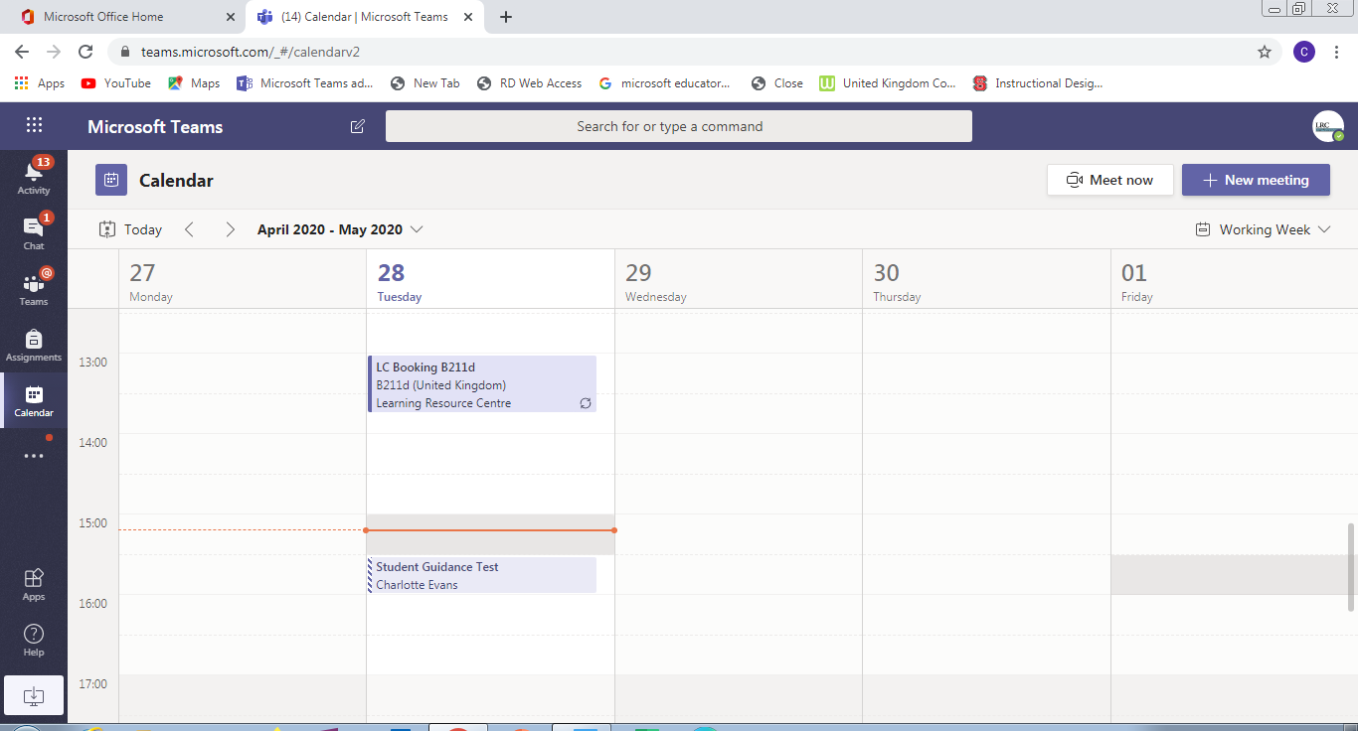
To join a live meeting (live lesson) go to the subject post page and a link to the meeting will be available. When it is time to join the meeting click on the link on the post page. Remember to check if this is the correct meeting for your teacher- this should be in the title of the meeting
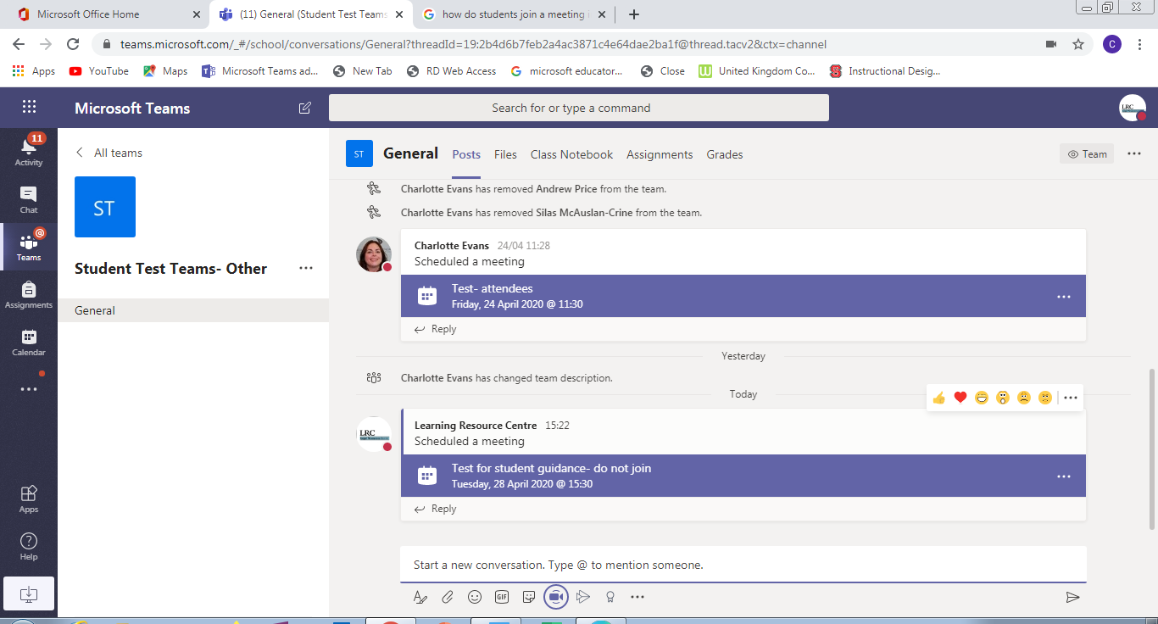

>Within the tool bar there is a Chat facility for typing questions

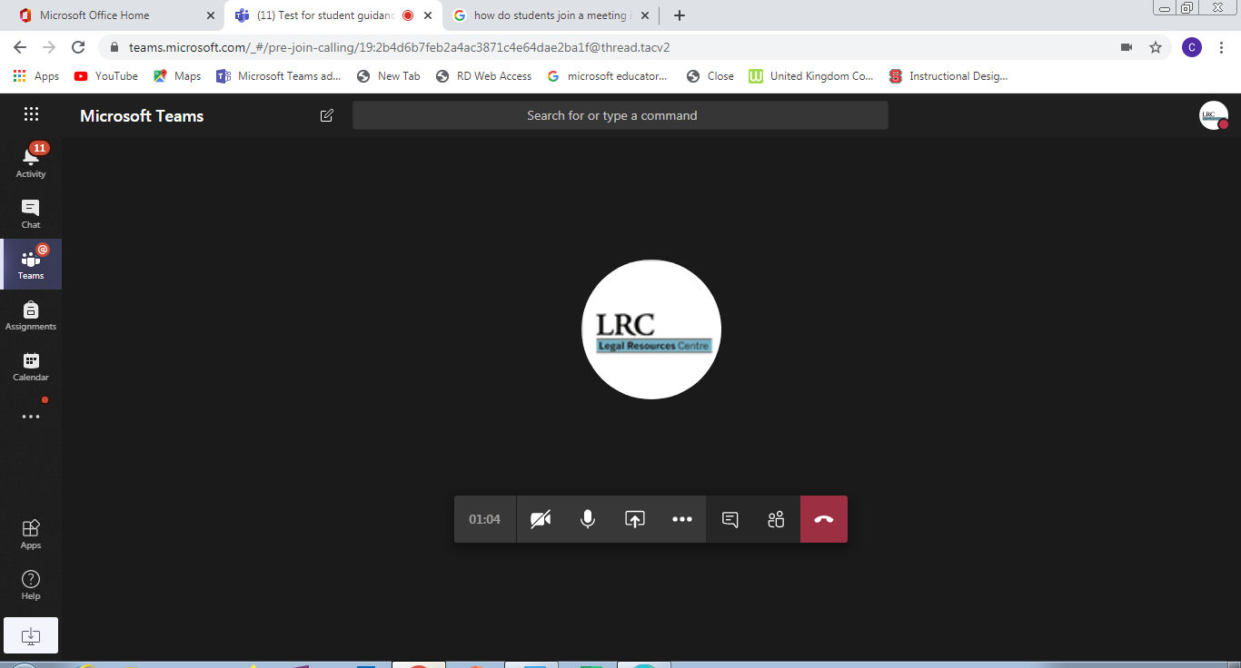
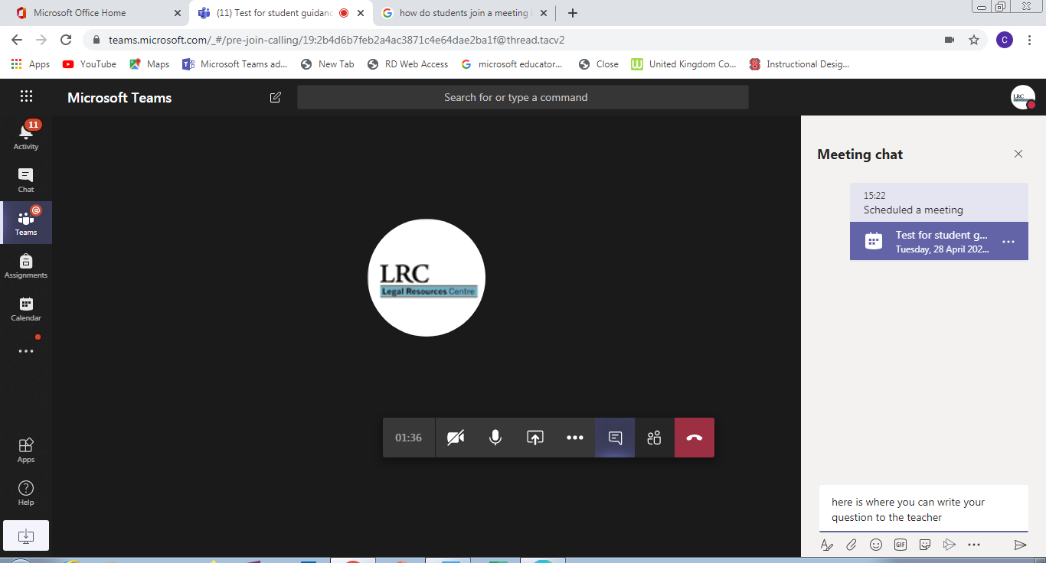

- Your mic is there for you and the teacher to turn on and off- please be guided by the teacher.
- There will be a type chat function to the right of the screen where you can ask questions rather than use the mic.
- Each live meeting (live lesson) will be recorded.
- Your teacher may use the video or share resources on the screen

If you miss the session a copy of the recorded will be posted in the post page along with all the questions and comments for you to review. It will also be found in the Files section in a folder called ‘Recordings’.

